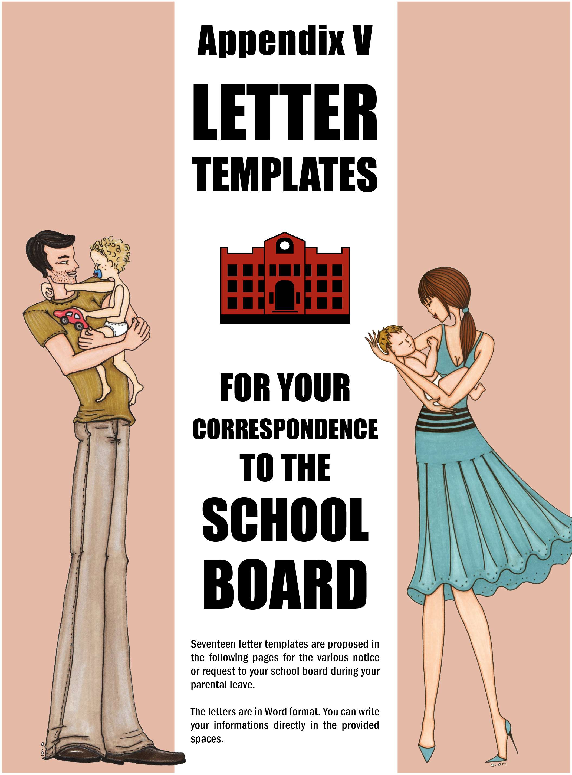

(Place and date)…………………...

Ms. / Mr.
Human Resources Department
(Name of) ………………….. School Board
(Address)…………………...

Reference #: (Employee Number or SIN) …………………...

Re: Request for a Maternity Leave

Dear Ms. / Mr. ,

In accordance with Article 5-4.11 of the Collective Agreement, I wish to inform you that my maternity leave will begin on …………………...... and end on ……………………..

Attached, you will find a medical certificate confirming my pregnancy and the projected due date for the birth of my baby.

Please send me my record of employment which will allow me to apply for the benefits I am entitled to under the Quebec Parental Insurance Plan (or the Service Canada Employment Insurance Plan, as the case may be).

I thank you in advance for your attention to this matter.

Sincerely yours,

(name and signature)

encl.: Medical Certificate
c.c.: Support staff union

(Place and date)…………………...

Ms. / Mr.
Human Resources Department
(Name of) ………………….. School Board
(Address)…………………...

Reference #: (Employee Number or SIN) …………………...

Re: Proof of QPIP or EIP Eligibility

Dear Ms. / Mr. ,

In accordance with Article 5-4.15 b) of the Collective Agreement, please find enclosed the proof that I am receiving maternity benefits from the …………………….(QPIP or EIP).

Sincerely yours,

(name and signature)

encl.: Proof of QPIP (or EIP) eligibility
c. c.: Support staff union

(Place and date)…………………...

Ms. / Mr.
Human Resources Department
(Name of) ………………….. School Board
(Address)…………………...

Reference #: (Employee Number or SIN) …………………...

Re: Request for a Temporary Reassignment or a Preventive Special Leave Covered by the CNESST

Dear Ms. / Mr. ,

In accordance with Article 5-4.20 of the Collective Agreement, I wish to be temporarily reassigned to another position or, if this is not possible, to be granted a preventive special leave.

Thank you for your attention to this matter.

Sincerely yours,

(name and signature)

encl.: CNESST form
c. c.: Support staff union

(Place and date)…………………...

Ms. / Mr.
Human Resources Department
(Name of) ………………….. School Board
(Address)…………………...

Reference #: (Employee Number or SIN) …………………...

RE: Request for an Advance Payment of CNESST Benefits

Dear Ms. / Mr. ,

I hereby contest the decision made by the CNESST to refuse my request for the special leave described in clause 5-4.20 of the Collective Agreement.

In consequence, I am requesting an advance payment based on the amount of benefits I am expected to receive.

Should the CNESST maintain its original decision, I will reimburse the amounts received in accordance with the modalities foreseen in clause 5-4.20 of the Collective Agreement.

Sincerely yours,

(nom et signature)

c. c. : Support staff Union

(Place and date)…………………...

Ms. / Mr.
Human Resources Department
(Name of) ………………….. School Board
(Address)…………………...

Reference #: (Employee Number or SIN) …………………...

Re: Request for a Modification to my Collective Health Insurance Plan

Dear Ms. / Mr.,

Following the birth (or the adoption) of my child on ………………….. , I wish to receive an application form that will allow me to modify my status in my health insurance plan.

*For a person who is covered by the SSQ life-insurance plan, but does not have coverage for a spouse or a child:
Moreover, I would like my spouse and my child to be added to my life insurance plan. It is my understanding that, in order to do so, I must send the completed form to the insurer before the 30th day following the birth (or the adoption) of my child.

Thank you for your attention to this matter.

Sincerely yours,

(name and signature)

c.c. Support staff union

(Place and date)…………………...

Ms. / Mr.
Human Resources Department
(Name of) ………………….. School Board
(Address)…………………...

Reference #: (Employee Number or SIN) …………………...

Re: Request for a Paternity or Adoption Leave

Dear Ms./Mr. ,

I wish to take a 5-day …………….. (paternity or adoption) leave in accordance with Article
5-4.23 or 5-4.32 of the Collective Agreement.

I will be taking my leave from …………. to ………….

Yours sincerely,

(name and signature)

c. c.: Support staff union

(Place and date)…………………...

Ms. / Mr.
Human Resources Department
(Name of) ………………….. School Board
(Address)…………………...

Reference #: (Employee Number or SIN) …………………...

Re: Request for a Paternity or Adoption Leave

Dear Ms. / Mr. ,

As the father of a child who was born (or adopted) on …………………... I wish to exercise my right to take a paternity (or adoption) leave that is covered by the QPIP (or Employment Insurance) for ...........weeks.

In accordance with Article 5-4.24 or 5-4.33 of the Collective Agreement, I intend to take my leave from ……………... to ……………….….

Sincerely yours,

(name and signature)

c. c.: Support staff union

(Place and date)…………………...

Ms. / Mr.
Human Resources Department
(Name of) ………………….. School Board
(Address)…………………...

Reference #: (Employee Number or SIN) …………………...

Re: Request for an unpaid Adoption Leave

Dear Ms. / Mr. ,

In accordance with Article 5-4.43 of the Collective Agreement, I wish to take a leave without pay in order to travel outside the province of Quebec for the purpose of adopting a child, I shall be taking this leave from …………………... until …………………..... inclusively.

Thank you for your attention to this matter.

Yours sincerely,

(name and signature)

c. c.: Support staff union

(Place and date)…………………...

Ms. / Mr.
Human Resources Department
(Name of) ………………….. School Board
(Address)…………………...

Reference #: (Employee Number or SIN) …………………...

Re: Request to Split my Leave

Dear Ms. / Mr. ,

Since my child is presently hospitalized, I want to temporarily suspend my ……….................. (maternity, paternity or adoption) leave in accordance with 5-4.08, 5-4.28 or 5-4.37 of the Collective Agreement. When my child returns home from the hospital I wish to continue my leave and will advise you of my child’s release from the hospital as soon as it occurs.

Thank you for your attention to this matter.

Sincerely yours,

(name and signature)

c.c.: Support staff union

(Place and date)…………………...

Ms. / Mr.
Human Resources Department
(Name of) ………………….. School Board
(Address)…………………...

Reference #: (Employee Number or SIN) …………………...

Re: Request for an Extended Leave

Dear Ms./Mr. ,

In accordance with Article 5-4.10, 5-4.30 or 5-4.39 of the Collective Agreement, I wish to request an extension of my ……………………. (maternity, paternity or adoption) leave for the care of my child. Please find attached, a medical certificate attesting to my child’s state of health.

Thank you for your consideration in this matter.

(name and signature)

encl.: Medical Certificate
c. c.: Support staff union

(Place and date)…………………...

Ms. / Mr.
Human Resources Department
(Name of) ………………….. School Board
(Address)…………………...

Reference #: (Employee Number or SIN) …………………...

Re: Request for a Vacation Leave Deferral

Dear Ms./Mr.,

In accordance with Articles 5-4.16 and 5-4.47 of the Collective Agreement, I wish to take my deferred annual vacation following my ………………… (maternity, paternity or adoption leave) and immediately preceding my extended leave without pay.

Sincerely yours,

(name and signature)

c. c.: Support staff union

(Place and date)…………………...

Ms. / Mr.
Human Resources Department
(Name of) ………………….. School Board
(Address)…………………...

Reference #: (Employee Number or SIN) …………………...

Re: Request for a leave without pay in order to extend a maternity, paternity or adoption leave

Dear Ms./Mr.,

In accordance with Article 5-4.44 of the Collective Agreement, I am requesting a leave without pay in order to extend my.......................... (maternity, paternity or adoption leave). For this purpose I am choosing the following option:

5-4.44 a)
□ a full-time leave without pay for 2 years
□ a part-time leave without pay for 2 years at .........% of my normal work-week. The part-time work-schedule I wish to have is as follows ......……………………

5-4.44 b)
□ a full-time leave without pay for one year
□ a part-time leave without pay for one year

Dates for the leave:
□ from..........................to the end of the present school year.
AND
□ for the next complete school year from July 1st to June 30th.
AND
□ for the second year: from July 1st until ..........................

(When combined, these three options make up a maximum of two full years.)

Sincerely yours,

(name and signature) …………………...

c. c.: Support staff union

(Place and date)…………………...

Ms. / Mr.
Human Resources Department
(Name of) ………………….. School Board
(Address)…………………...

Reference #: (Employee Number or SIN) …………………...

Re: Request for a modification to my leave without pay following my maternity paternity or adoption leave.

Dear Ms/Mr.,

In accordance with Article 5-4.44 a) of the Collective Agreement, I would like to request a modification to the leave without pay that I am taking following my ……………… (maternity paternity or adoption leave). In order to do this, I wish to choose the following option:

Modification to my unpaid leave:
□ from a full-time leave without pay to a part-time leave without pay at ........ % of my regular work-week, starting ……………….

□ from a part-time leave without pay to a full-time leave without pay, starting …………

□ from a part-time leave without pay at …… % of my regular work-week to another part-time leave without pay at ...... % of my regular work-week, starting on………….

Thank you for your attention to this matter.

Sincerely yours,

(name and signature)

c. c.: Support staff union

(Place and date)…………………...

Ms. / Mr.
Human Resources Department
(Name of) ………………….. School Board
(Address)…………………...

Reference #: (Employee Number or SIN) …………………...

Re: Participation in the Complementary Health Insurance Plans

Dear Ms./Mr.,

During my leave without pay, in accordance with Article 5-4.46 of the Collective Agreement, I wish to continue participating in the Complementary Health Insurance plans that apply to me.

Thank you for your attention to this matter.

Sincerely yours,

(name and signature)

c. c.: Support staff union

(Place and date)…………………...

Ms. / Mr.
Human Resources Department
(Name of) ………………….. School Board
(Address)…………………...

Reference #: (Employee Number or SIN) …………………...

Re: Notice of my return to work

Dear Ms./Mr.,

In accordance with Article 5-4.52 of the Collective Agreement, I wish to inform you of my intention to return to work on ………….

Thank you for your attention to this matter.

Yours sincerely,

(name and signature)

c. c.: Support staff union

(Place and date)…………………...

Ms. / Mr.
Human Resources Department
(Name of) ………………….. School Board
(Address)…………………...

Reference #: (Employee Number or SIN) …………………...

Re: Notice of a return to work before the planned date, thus ending the unpaid leave that followed my maternity, paternity, or adoption leave.

Dear Ms./Mr.,

In accordance with Article 5-4.52 of the Collective Agreement, I wish to terminate my leave without pay prior to the planned date. Therefore, I would like to inform you that I shall be returning to work on………………...

Thank you for your attention to this matter.

Sincerely yours,

(name and signature)

c. c.: Support staff union

(Place and date)…………………...

Ms. / Mr.
Human Resources Department
(Name of) ………………….. School Board
(Address)…………………...

Reference #: (Employee Number or SIN) …………………...

Re: Request for a leave without pay for parental responsibilities

Dear Ms. / Mr.

In accordance with Article 5-4.49 of the Collective Agreement, I am requesting a leave without pay for parental responsibilities.

□ a full-time leave without pay for ……. weeks
□ a part-time leave without pay for …… weeks at .........% of my normal work-week.

The schedule I would like to have is the following …………

This leave will end on …….

Thank you for your attention to this matter.

Sincerely yours,

(name and signature)

c. c.: Support staff union

